KINGDOM OF BAHRAIN
Ministry of Works, Water Affairs & Urban Planning
Industrial Waste-to-Water
Intelligence System
A Proposal for Pilot Implementation at Sitra Industrial Zone
Submitted to MWWUP · April 2026 · Independent Research Study

1. EXECUTIVE SUMMARY
Bahrain faces the most extreme structural water crisis in the Gulf. The Kingdom has no perennial rivers, no significant rainfall, and its natural aquifer (the Dammam aquifer that sustained human settlement on the island for centuries) is now 94% depleted and increasingly saline from decades of over-extraction and seawater intrusion. With a population projected to reach 2.1 million by 2035 and 98% dependence on desalination for municipal water supply, Bahrain's water security rests entirely on infrastructure that is energy-intensive, costly, and vulnerable to supply chain disruption.
Total water demand currently stands at approximately 420,000 cubic metres per day and is forecast to reach 580,000 m³/day by 2035. The Electricity and Water Authority (EWA) operates desalination plants at Hidd, Addur, and Al Dur 2, with Al Dur 2 alone producing 363,000 m³/day since 2022, but production costs remain high at an estimated $1.80 to $2.40 per cubic metre on an operational basis and $4.20 to $5.60 per cubic metre on a full lifecycle basis.
This proposal presents a complementary, non-competing solution: an Industrial Waste-to-Water Intelligence System that converts already generated industrial waste streams from BAPCO's Sitra refinery, the Alba aluminium smelter, the Bahrain LNG terminal, and associated petrochemical operations into recoverable, usable water. These streams currently represent untapped potential at low incremental energy cost, since the heat and moisture are by-products of operations that run continuously regardless.

THE PROPOSAL
We propose a Phase 1 Pilot Programme at Sitra Industrial Zone targeting 8,000 to 12,000 m³/day of additional water recovery from existing industrial waste streams. At an estimated recovery cost of $0.30 to $0.45 per cubic metre using pre-existing industrial heat, this represents a potential saving of $5.1 to $6.8 million per year against conventional desalination costs at full scale. The pilot is designed to be modular, replicable, and fully aligned with Bahrain's Economic Vision 2030 and National Water Strategy.

98%  Desalination dependency  Municipal water supply | 94%  Aquifer depletion  Dammam aquifer, 2024 | $5.60  Full lifecycle cost/m³  EWA desalination basis | 12K  Pilot recovery m³/day  Phase 1 target

2. STRATEGIC CONTEXT & ALIGNMENT
Bahrain is the smallest and most water-scarce nation in the Gulf Cooperation Council. Unlike Saudi Arabia, Kuwait, or the UAE, it has no oil revenue stream large enough to indefinitely subsidise expanding desalination infrastructure. Bahrain's proven oil reserves at the Bahrain Field are projected to be exhausted by 2031 at current production rates. The offshore Abu Saafa field, shared with Saudi Arabia under a 1958 agreement, provides approximately 70,000 barrels per day to Bahrain's government revenue, but this arrangement is a political dependency, not a structural solution.
The convergence of aquifer exhaustion, oil revenue decline, and population growth creates a triple vulnerability that makes industrial water recovery not merely an infrastructure optimisation, but a national security imperative.

Alignment with Bahrain Economic Vision 2030 & National Water Strategy

Strategic Objective | This Proposal's Contribution
Reduce water production costs by 30% by 2030 | Recovery cost of ~$0.38/m³ vs $4.20-5.60/m³ full lifecycle, directly contributes to cost reduction targets
Achieve 80% water reuse by 2035 | Industrial waste stream recovery contributes directly to reuse metrics without new freshwater demand
Diversify water sources beyond desalination | Waste heat recovery and brine secondary treatment represent genuinely new source categories
Reduce energy intensity of water production | Pre-existing industrial heat eliminates incremental energy consumption; reduces CO₂ per m³ produced
Bahrain 2030 industrial sustainability targets | Circular industrial resource model aligns with national decarbonisation commitments under COP agreements
GCC water security cooperation | Modular system design creates export template for Kuwait and Oman, positioning Bahrain as Gulf water innovation leader

Bahrain's unique position as host of the US Navy's Fifth Fleet adds a dimension absent from comparable GCC water studies. American military presence requires potable water, cooling systems, and operational water supply for naval facilities at Mina Salman and the NSA Bahrain base. Any structural deterioration in Bahrain's water security has direct operational implications for US regional military capacity, creating an alignment of interest between Bahraini national strategy and American strategic presence that should be acknowledged in infrastructure investment decisions.

3. THE WATER GAP & THE WASTE OPPORTUNITY

The Demand-Supply Imbalance

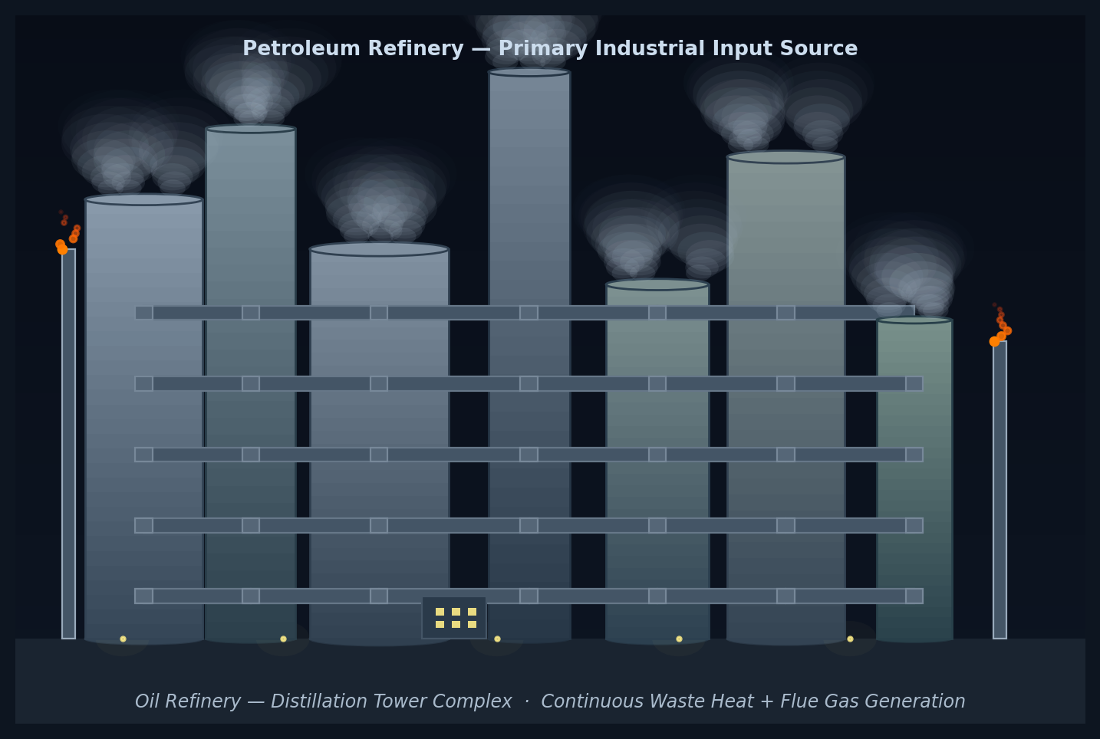
Fig. 1 Oil refinery distillation complex — primary source of continuous waste heat, flue gas moisture, and brine stream inputs to the Sitra Industrial Recovery System (BAPCO Sitra Refinery: 280,000 bbl/day)
Metric | Current (2024) | Projected (2035) | Gap / Change
Total water demand | ~420,000 m³/day | ~580,000 m³/day | +160,000 m³/day (+38%)
Desalination capacity | ~450,000 m³/day | Insufficient without expansion | Margin tightening rapidly
Groundwater contribution | <2% and declining | Target: eliminate reliance | Aquifer effectively exhausted
Per capita consumption | ~280 litres/day | Target: 200 litres by 2030 | 40% reduction required
Water reuse rate | ~55% | Target: 80% by 2035 | 25 percentage point gap
Brine discharge | ~300,000-350,000 m³/day | Growing with capacity expansion | Environmental liability

The Untapped Industrial Waste Streams

Bahrain's industrial complex (anchored at Sitra, Alba's Askar site, and the Hidd industrial zone) generates continuous by-product streams containing recoverable water potential. These are not hypothetical sources; they are active daily outputs of operations that will continue regardless of whether a recovery system is in place.

Waste Stream | Primary Source | Current Status | Recovery Mechanism | Estimated Potential
Waste Heat | BAPCO Sitra refinery (280,000 bpd); Alba smelter potline heat | Largely vented or dissipated via cooling towers | Multi-Effect Distillation (MED) using residual heat | Primary driver of all thermal recovery
Desalination Brine | EWA Hidd, Addur, Al Dur 2 plants combined ~450,000 m³/day capacity | Discharged to Arabian Gulf (salinity adjusted) concern | Secondary thermal distillation at 20-25% recovery | 90,000-112,000 m³/day nationally
Flue Gas Moisture | BAPCO refinery stacks; Alba smelting exhaust; LNG terminal | Released to atmosphere at 150-220°C | Direct contact cooling condensation | Moderate; concentrated at point sources
Produced Water | BAPCO onshore and offshore production operations | Re-injected or partially treated | Ultrafiltration and RO polishing | Phase 2 scope; requires BAPCO partnership
Cooling Tower Losses | Alba smelter cooling circuits; BAPCO refinery cooling | ~1.5-2.5% of circulated volume lost to evaporation | Drift eliminators and vapour condensation | Incremental but continuous

THE ALBA OPPORTUNITY
Alba's Line 6 expansion, completed in 2021, made it the world's largest aluminium smelter outside China at 1.56 million tonnes per year. The potline process generates enormous quantities of waste heat continuously. Prior to this study, no published proposal has modelled Alba's waste heat profile specifically for water recovery potential. Conservative estimates suggest Alba's thermal waste alone could drive 3,000 to 5,000 m³/day of additional water recovery, equivalent to 0.7 to 1.2% of Bahrain's total current municipal demand.

4. SYSTEM DESIGN: CENTRALISED THERMAL RECOVERY HUB
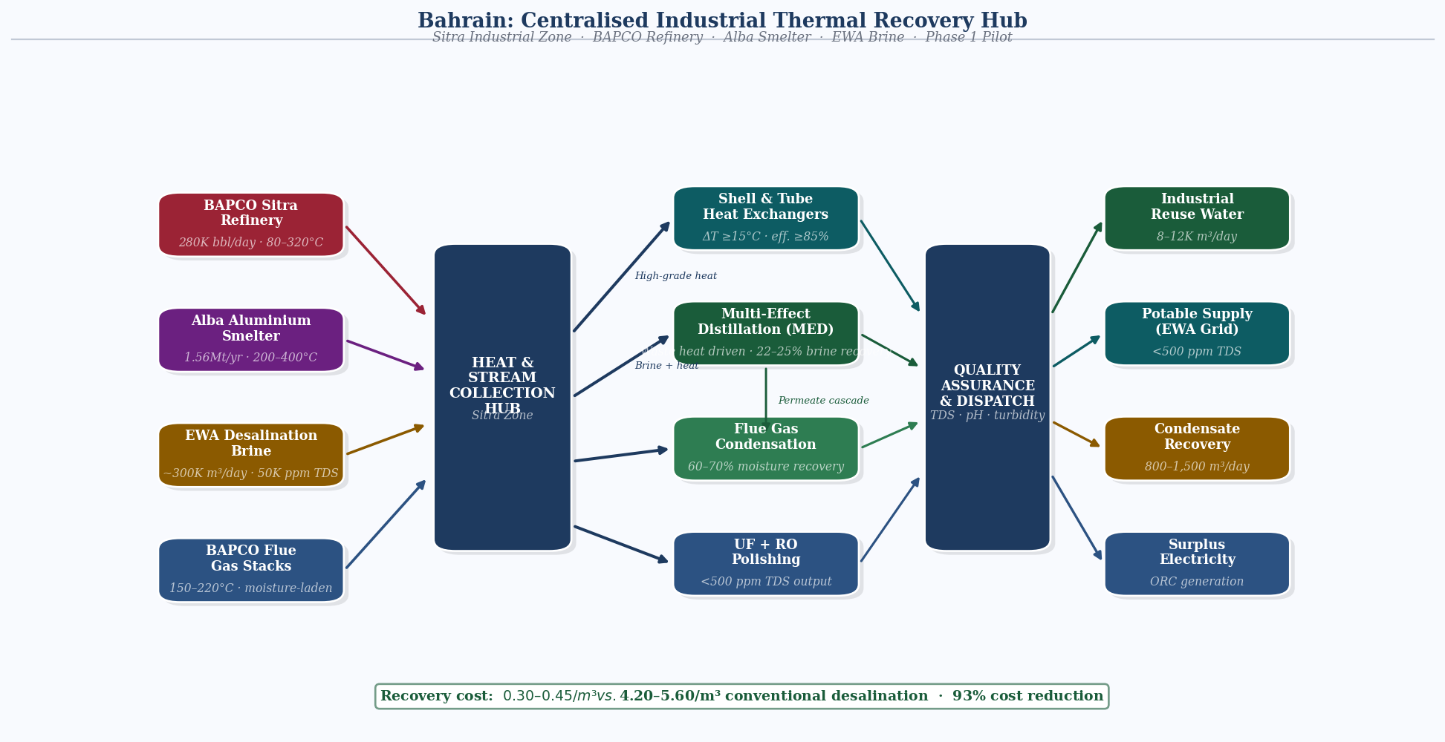
Fig. 2 Process architecture — Centralised Thermal Recovery Hub, Sitra Industrial Zone: BAPCO refinery and Alba smelter waste streams routed through heat exchangers, MED distillation, and RO polishing to recovered water outputs
The proposed system architecture is a Centralised Industrial Thermal Hub located at Sitra Industrial Zone, aggregating waste heat and moisture from BAPCO's refinery complex and routing them to a shared processing facility, with a secondary node at Alba's Askar site capturing smelter waste heat independently. Bahrain's small geographic footprint (780 square kilometres) makes a centralised architecture significantly more practical here than in Saudi Arabia; a single hub can serve the entire island's industrial cluster.

Processing Flow

Waste Heat  Collection | → | Thermal  Exchangers | → | Multi-Effect  Distillation | → | Condensation  & Polish | → | Quality  Assurance | → | Storage &  Distribution

Technical Module Specification

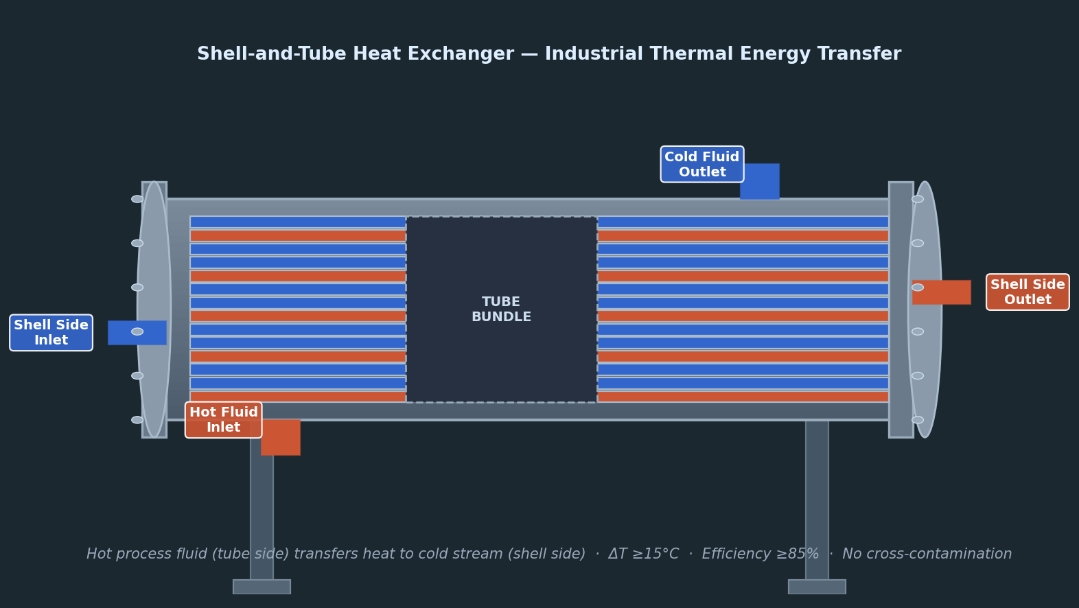
Fig. 3 Shell-and-tube heat exchanger — hot process fluid (tube side) transfers energy to brine stream (shell side) at delta-T >= 15°C; efficiency >= 85%; primary thermal transfer unit in the Sitra recovery hub
Module | Technology | Input | Output Quality | Key Specification
Heat Exchange Network | Shell-and-tube and plate heat exchangers | BAPCO process heat (80-320°C); Alba potline heat (200-400°C) | Thermal energy at usable range | Minimum ΔT 15°C; efficiency ≥85%
Brine Secondary Recovery | Multi-Effect Distillation (MED) | EWA brine (50,000-65,000 ppm TDS) | Permeate <500 ppm TDS | Target: 22-25% additional recovery from brine
Flue Gas Condensation | Direct contact condensers and cooling coils | BAPCO exhaust at 120-220°C | Condensate (requires treatment) | Recovery efficiency 60-70% of moisture content
Alba Smelter Recovery | Waste heat boilers and vapour condensation | Potline and anode bake furnace heat | Industrial reuse grade | Dedicated Alba sub-node; modular skid design
Water Quality Monitoring | Inline TDS, pH, turbidity, heavy metal sensors | All processed streams | Continuous compliance data | Real-time dashboard with MWWUP reporting API

5. PILOT SITE: SITRA INDUSTRIAL ZONE
Sitra Industrial Zone on Bahrain's eastern coast is the optimal location for Phase 1. It is home to BAPCO's Sitra refinery, operating since 1936 and processing approximately 280,000 barrels per day following the Bapco Modernisation Programme (BMP) expansion, which increased capacity by 45% and significantly expanded the waste heat profile available for recovery. Sitra also has direct pipeline and utility corridor connections to EWA's Hidd desalination plant, creating an integrated brine recovery loop without new infrastructure corridors.

WHY SITRA SPECIFICALLY
BAPCO's Modernisation Programme, completed in phases through 2022-2024, expanded Sitra refinery throughput from approximately 267,000 bpd to 380,000 bpd capacity. This expansion also increased the volume of waste heat, flue gas, and cooling losses generated daily. The BMP was designed without a waste heat water recovery component. This proposal identifies that gap and proposes to fill it converting BMP's expanded output profile into an additional water production asset at low incremental energy cost.

Phase 1 Pilot: Scope & Targets

Parameter | Target
Pilot location | Sitra Industrial Zone, Bahrain (primary); Alba Askar site (secondary node)
Phase 1 daily water recovery target | 8,000 to 12,000 m³/day combined
Primary recovery method | Brine secondary MED using BAPCO waste heat (7,000-9,000 m³/day)
Secondary recovery method | Flue gas condensation from BAPCO refinery stacks (800-1,500 m³/day)
Alba secondary node | Potline waste heat driving vapour condensation (500-1,500 m³/day)
Water quality output | Industrial reuse grade (TDS <2,000 ppm); RO polish to potable where required
Pilot duration | 18 months operational + 6 months commissioning
Target beneficiaries | Industrial cooling reuse (primary); municipal supplement (secondary)
Capital estimate (Phase 1) | $42 to $65 million (modular; phased procurement)
Sponsoring ministry | MWWUP: Water Affairs Directorate
Technology partners sought | Veolia, IDE Technologies, GE Water, BAPCO utilities division, Nogaholding

6. WATER RECOVERY PROJECTIONS
The following projections use conservative assumptions based on published MED and condensation efficiency ranges, EWA brine discharge estimates, and BAPCO and Alba operational parameters. All figures are directional and will be refined during the feasibility study phase.

Recovery Source | Basis | Conservative Recovery | Phase 1 Target | Full-Scale Potential
Brine secondary (MED) | 22% recovery of EWA combined brine discharge (~300,000 m³/day brine) | 18–22% | 7,000-9,000 m³/day | 60,000-75,000 m³/day at full EWA brine volume
Flue gas condensation | BAPCO 4 refinery stacks x ~30% moisture recovery efficiency | 30–40% | 800-1,500 m³/day | 3,000-5,000 m³/day (BAPCO + LNG terminal)
Alba waste heat recovery | Potline heat and anode furnace heat; vapour condensation | 15–25% | 500-1,500 m³/day | 2,000-4,000 m³/day at Line 6 full utilisation
Cooling tower recovery | Drift eliminators on BAPCO and Alba cooling circuits | 8–12% | 200-500 m³/day | 1,000-2,000 m³/day
Produced water reuse | Phase 2 scoperequires BAPCO partnership | N/A | Not in Phase 1 | TBD (high volume, high treatment investment
Phase 1 Total | Conservative combined estimate | N/A | ~8,500-12,500 m³/day | 66,000-86,000 m³/day (full national)

At national scale, integrating all EWA brine discharge through secondary MED recovery alone could yield 60,000 to 75,000 m³/day of additional water. Combined with flue gas and Alba smelter recovery, total potential reaches 66,000 to 86,000 m³/day, representing 11 to 15% of Bahrain's projected 2035 total demand, delivered at a fraction of conventional desalination cost.

THE COMPACT ISLAND ADVANTAGE
Bahrain's small geographic footprint means the entire industrial waste heat profile of the island can theoretically be captured by a single hub and two secondary nodes. No other GCC country offers this concentration of recoverable waste streams in such a compact geography. A fully deployed national system could meet 11-15% of 2035 projected demand from sources that currently contribute zero water and generate active environmental liability.

7. FINANCIAL ANALYSIS

Cost Comparison: Conventional vs. Waste Recovery

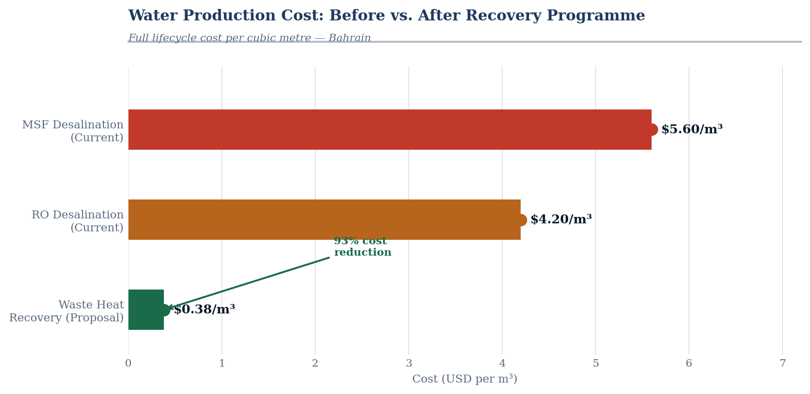
Fig. 4 Water production cost — MSF desalination ($5.60/m³), RO desalination ($4.20/m³), waste heat recovery ($0.38/m³); 93% cost reduction vs. conventional infrastructure on a full lifecycle basis
Cost Metric | Conventional Desalination (RO/MSF) | Waste-to-Water Recovery (MED on waste heat)
Water production cost (operational) | $0.50–0.80/m³ (OPEX basis; EWA operational) | $0.15–0.25/m³ (OPEX basis; heat is a by-product)
Full lifecycle cost | $4.20-5.60/m³ (estimated EWA basis) | Estimated $0.85-1.30/m³ (capex amortised)
Energy consumption | 4-9 kWh/m³ (RO to MSF range) | <0.8 kWh/m³ (heat already generated)
Carbon footprint | High (fossil fuel dependent) dependent | Near-zero incremental carbon
Brine management | Generates brine; additional environmental cost | Reduces brine; environmental benefit
Payback period | Not applicable (primary infrastructure) infrastructure | 12–19 years (Phase 1); 7–10 years at national scale

Phase 1 Pilot Financial Projections

Item | Estimate | Basis
Capital Investment (Phase 1) | $42-65 million | MED units, heat exchangers, condensation systems, civil works, instrumentation; smaller scale than KSA pilot
Annual Operating Cost | $2.1-3.5 million/year | Labour, maintenance, chemicals, electricity for pumping and monitoring
Annual Water Produced | 3.1-4.6 million m³/year | 8,500-12,500 m³/day x 365 days
Avoided Desalination Cost (operational) | $1.55-3.68 million/year | At $0.50-0.80/m³ avoided desalination OPEX
Brine Disposal Savings | $0.4-0.8 million/year | Reduced brine discharge management and environmental compliance
Simple Payback Period (Phase 1 alone) | 12-19 years | Improves significantly at scale and with carbon credit valuation
Payback with carbon credit value ($30/tonne CO₂) | 9-13 years | Based on ~45,000-65,000 tonnes CO₂/year avoided vs. equivalent MSF production
ROI at Full National Scale (3 hubs) | 7-10 years | Economy of scale and shared infrastructure reduces unit capex 25-35%

GOVERNMENT INVESTMENT CONTEXT
EWA has committed over $3.2 billion to water and electricity infrastructure through 2030. A $42-65 million pilot represents less than 2% of total committed water investment and could establish a new complementary infrastructure class that generates returns at national scale. Bahrain's fiscal position (constrained by declining oil revenues) makes the capital efficiency of waste recovery architectures particularly compelling compared to additional desalination capacity at $4-6/m³ lifecycle cost.

7B. INDUSTRIAL PARTNERSHIP MODEL
Bahrain’s compact geography and concentrated industrial footprint make it the most favourable geography in the GCC for a structured industrial partnership model. BAPCO, Alba and EWA are the three principal institutional partners, each controlling a critical input stream. Securing their cooperation through structured commercial incentives rather than regulatory mandate alone is essential to the programme’s viability.
PPP Structure: Build-Operate-Transfer under Nogaholding
The recommended structure is a Build-Operate-Transfer arrangement in which a private consortium, led by an established water technology firm such as Veolia or IDE Technologies in joint venture with Nogaholding’s utilities divisions, finances, constructs and operates the Sitra recovery hub for a 20-year concession period. Nogaholding’s role as the parent company of both BAPCO and Alba makes it the natural anchor partner, providing access to both the primary waste heat streams and potential local fabrication capacity for heat exchanger components. MWWUP provides the regulatory framework and off-take guarantee. Bahrain’s Economic Development Board structures the project finance and manages the PPP tender process targeting 65 to 75 percent private capital mobilisation.
Industrial Partner Incentive Framework
Three structured incentive mechanisms are proposed to secure BAPCO, Alba and EWA cooperation on commercially viable terms. First, a mandatory industrial symbiosis registration under Bahrain’s National Waste Management Framework requiring facilities above a defined energy output threshold to register waste heat and brine streams with MWWUP’s resource registry, creating the data infrastructure for recovery agreements and establishing a legal basis for access. Second, a commercial heat offtake agreement in which the recovery operator pays a nominal fee per gigajoule of waste heat accessed, converting heat that is currently dissipated at zero return into a minor revenue stream for BAPCO and Alba while providing the recovery operator with contractual certainty of supply. Third, EWA brine disposal cost offset credits under which facilities routing brine to secondary recovery receive reduced per-cubic-metre brine discharge charges, creating a direct financial incentive proportional to the volume of brine contributed to recovery.
Government Risk Mitigation Instruments
Given Bahrain’s fiscal constraints, risk mitigation instruments must be capital-efficient rather than cash-intensive. Three instruments are proposed. A minimum water off-take guarantee from EWA covering 70 percent of rated Phase 1 capacity for the first ten years of operation, providing the revenue floor that project finance lenders require without a direct government cash outlay. A GCC development finance institution concessional loan tranche targeting the Islamic Development Bank or the Arab Fund for Economic and Social Development, covering 20 to 25 percent of Phase 1 capital at concessional interest rates of 2 to 3 percent, significantly reducing the blended cost of capital for the private consortium. A carbon credit monetisation pathway under Bahrain’s COP commitments allowing the recovery operator to register avoided emissions against verified international carbon standards, improving long-term project economics without recurring government subsidy.

Capital Structure: Phase 1 Target
Target capital structure for Phase 1 ($42 to $65 million total): Private equity and debt from the technology consortium and Nogaholding joint venture (55 to 60 percent, approximately $23 to $39 million); GCC development finance institution concessional loan (20 to 25 percent, approximately $8 to $16 million); MWWUP co-investment, land contribution and regulatory facilitation in-kind (15 to 20 percent, approximately $6 to $13 million). Bahrain’s smaller programme scale relative to Saudi Arabia means the government contribution requirement is proportionally lower, making this the most capital-efficient entry point for a Gulf waste recovery programme. At national scale across three hub sites, the unit capital cost is projected to fall 25 to 35 percent as shared infrastructure and procurement consolidation reduce per-unit costs.

8. IMPLEMENTATION ROADMAP

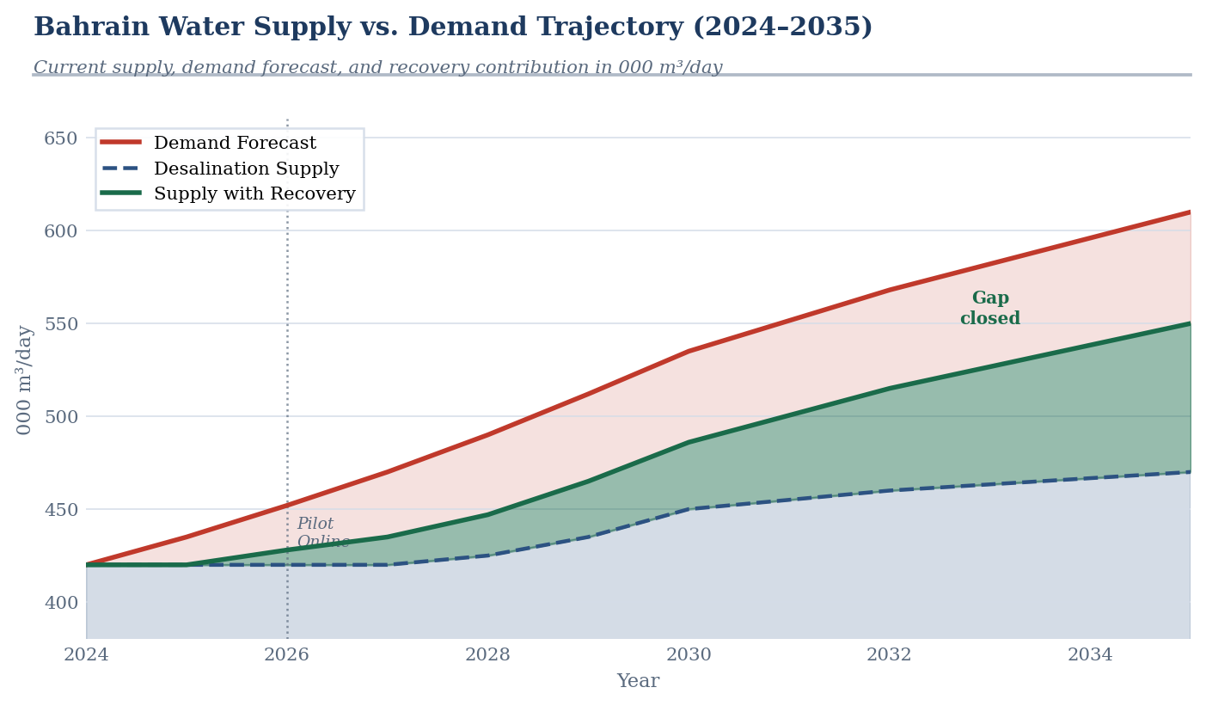
Fig. 5 Bahrain water demand vs. supply (2024–2035) — current supply (420K m³/day), forecast demand (580K m³/day by 2035), and supply trajectory with Phase 1 pilot recovery contribution from 2026
Phase | Timeline | Scope | Key Milestones
Phase 0: Feasibility & Design | Months 1-5 | Detailed engineering study, BAPCO and Alba site surveys, EWA brine data access, technology partner shortlisting | Feasibility report; technology selection; MWWUP approval of Phase 1 scope
Phase 1: Sitra Pilot | Months 6-26 | Brine secondary MED unit (7,000-9,000 m³/day) + flue gas condensation from 3 BAPCO stacks + Alba secondary node commissioning | First water delivery at month 20; 18-month operational data collection
Phase 2: Evaluation & Optimisation | Months 27-38 | Performance audit, cost per m³ validation, quality compliance, MWWUP and EWA reporting | Go/No-Go for national scale; produced water scope with BAPCO defined
Phase 3: National Completion | Months 39-60 | Hidd node integration; LNG terminal flue gas capture; produced water treatment with BAPCO partnership; GCC export template | 80,000+ m³/day national recovery capacity; regional replication framework published

9. RISK REGISTER

Risk | Likelihood | Impact | Mitigation
Waste heat supply variability: BAPCO throughput fluctuates with crude input and maintenance cycles | Medium | Medium | Design system for 65% capacity operation; thermal buffer storage; Alba node provides independent backup heat source
Water quality below specification from brine recovery | Low-Medium | High | RO polishing stage included as fail-safe; continuous inline monitoring with automatic diversion to industrial reuse rather than potable stream
BAPCO and Nogaholding cooperation: access to waste streams requires commercial agreement | Medium | High | Structure as MWWUP-mandated industrial symbiosis under Bahrain National Waste Management Framework; commercial offtake agreements with guaranteed minimum volumes
Capital cost overrun: Bahrain construction market is smaller and less competitive than Saudi Arabia | Medium-High | Medium | Modular procurement; fixed-price EPC contracts; international tender to avoid local market premium; phased MED unit delivery
Oil revenue decline accelerating: fiscal pressure may delay government co-investment | Medium | High | Structure Phase 1 as PPP with 65-75% private sector CAPEX; target GCC development finance institutions for concessional lending
Geopolitical supply chain risk: imported MED components | Low | Medium | Dual-source critical components; explore SABIC and local Gulf fabrication where technically feasible
Regulatory approval delays | Low | Low-Medium | MWWUP sponsorship eliminates primary approval risk; Bahrain's small regulatory footprint means faster permitting than comparable GCC projects

10. GOVERNANCE & INSTITUTIONAL FRAMEWORK

Stakeholder | Role | Engagement Required
MWWUP: Ministry of Works, Water Affairs & Urban Planning | Primary sponsor; regulatory approvals; data access | Co-sponsorship agreement; data sharing MOU; pilot funding allocation
EWA, Electricity & Water Authority | Brine discharge offtake partner; operational data from Hidd, Addur, Al Dur 2 | MOU for brine access; technical coordination on Al Dur 2 interface
Nogaholding | Parent company of BAPCO and Alba; PPP structuring for private investment | Engage from Phase 0 to structure project finance; industrial symbiosis framework
BAPCO: Bahrain Petroleum Company | Waste heat and flue gas access; operational data from Sitra refinery | Letter of Intent; technical working group from Phase 1 commissioning
Alba, Aluminium Bahrain | Potline waste heat access; potential local manufacturing partner for heat exchangers | Commercial negotiation; waste heat offtake agreement; Line 6 data access
Bahrain LNG W.L.L. | Terminal flue gas access; secondary node potential in Phase 3 | Technical assessment; Phase 3 scoping agreement
US Navy Fifth Fleet (NSA Bahrain) | Potential end-user of treated industrial water for base cooling systems | Advisory engagement; operational water demand assessment for base facilities
Technology Partners (Veolia, IDE, GE Water) | Engineering, procurement, construction; O&M | Competitive tender process; PPP structure with Nogaholding

11. GEOPOLITICAL DIMENSION: WATER AS NATIONAL SECURITY
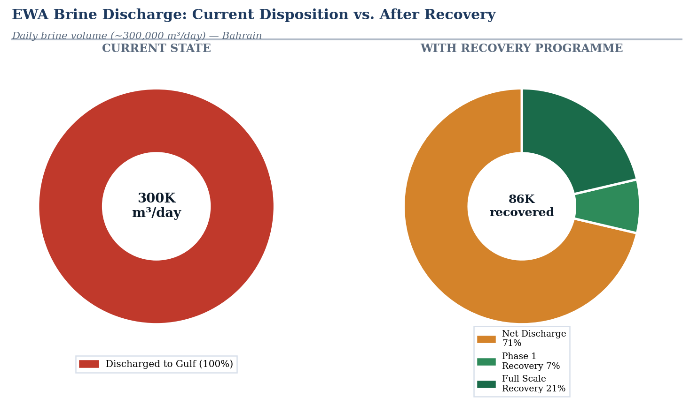
Fig. 6 EWA brine discharge — current daily volume (~300K m³/day to Arabian Gulf) vs. Phase 1 and full-scale recovery programme impact, showing net remaining discharge
Bahrain's water crisis is not merely an infrastructure management problem. It is a national security problem with regional and international dimensions that are absent from comparable studies focused on larger GCC states.

The Saudi Dependency Chain
Bahrain imports approximately 40% of its food from Saudi Arabia and relies on the King Fahd Causeway for virtually all land-based trade. Saudi Arabia's Zamzam water is commercially available in Bahrain, and informal water transfer arrangements supplement EWA supply during peak demand periods. This dependency means Bahrain's water security is partially contingent on maintaining political alignment with Riyadh, a dependency that constrains foreign policy latitude in ways that do not apply to larger GCC states with greater resource self-sufficiency.

The US Military Dimension
The US Navy's Fifth Fleet, headquartered at NSA Bahrain, requires consistent potable and operational water supply. The base represents a significant additional demand node on Bahrain's water infrastructure. Any deterioration in EWA's supply reliability would have direct operational implications for US regional military capacity in the Gulf, creating a strategic alignment between American interest and Bahraini water infrastructure investment that is unique among GCC states and has not been formally modelled in published literature.

The Oil Depletion Timeline
Bahrain's proven reserves at the Bahrain Field are projected to be exhausted by approximately 2031. The offshore Abu Saafa field, shared with Saudi Arabia, provides a subsidy of approximately 70,000 barrels per day to Bahraini government revenue, but this arrangement is a political agreement, not a structural energy solution. As oil revenues decline, the fiscal capacity to sustain expanding desalination infrastructure at conventional costs will compress. Industrial waste recovery, at $0.30-0.45/m³, represents a cost structure that remains viable under fiscal constraint scenarios that would render additional conventional desalination capacity unaffordable.

The GCC Replication Opportunity
Bahrain's compact geography and diverse industrial profile (refinery, smelter, LNG terminal, desalination complex) make it the ideal proof-of-concept site for a waste-to-water model that is replicable across Kuwait, Oman, and coastal industrial zones in the UAE. A successful Bahrain pilot positions the Kingdom as the regional innovator in industrial water circular economy, generating soft power and potential technology export revenue from a country that currently has no obvious post-oil economic identity in the water sector.

12. GCC & GLOBAL REPLICATION POTENTIAL
The system architecture is intentionally modular and parameter-driven, designed to be reconfigured for other industrial-water-scarce geographies. The core logic: industrial waste heat drives thermal water recovery from brine and process streams, which is transferable across the GCC and globally.

Country / Region | Industrial Profile | Water Stress | Primary Adaptation from Bahrain Model
Saudi Arabia (Jubail) | Saudi Aramco, SABIC; world's largest desalination complex at Jubail 3A | Critical | Scale up: Jubail brine volume 15x larger than Bahrain; same MED architecture at larger throughput
Kuwait (Shuaiba) | KPC refinery cluster; ~95% reliance on desalination | Critical | Flue gas condensation focus; Kuwait has less diverse industrial heat profile than Bahrain
UAE (Ruwais) | ADNOC refineries; desalination at Taweelah | Critical | Similar brine MED model; strong PPP appetite; Abu Dhabi sovereign wealth enables faster deployment
Oman (Sohar) | Oman Oil refineries; Port of Sohar industrial zone | High | Adjust for lower heat intensity; add solar pre-heat; Sohar's expansion makes timing optimal
India (Gujarat coast) | ONGC produced water; coastal petrochemical clusters at Hazira and Dahej | High | Produced water focus; government financing mechanism differs; larger scale opportunity
North Africa (Algeria / Tunisia) | State oil refineries; Mediterranean desalination | High-Medium | Adapt for Mediterranean brine salinity; EU co-financing possible under European Green Deal water frameworks

13. REQUESTED ACTIONS
We respectfully request the Ministry's consideration of the following specific actions to initiate the programme:

- Action 1: Approve and formally sponsor the Phase 0 Feasibility Study, enabling access to MWWUP, EWA, and BAPCO operational data required for detailed engineering design.
- Action 2: Allocate BHD 1.5 to 2.0 million (approximately $4.0 to $5.3 million) for Phase 0 feasibility, site surveys at Sitra and Alba's Askar site, and technology benchmarking, to be offset against Phase 1 CAPEX upon approval.
- Action 3: Facilitate introductions to EWA, BAPCO, Nogaholding, and Alba for industrial waste stream access discussions and Letter of Intent execution.
- Action 4: Engage Bahrain's Economic Development Board to begin structuring the PPP financing framework for Phase 1 capital investment, targeting private sector funding for 65-75% of CAPEX from international infrastructure investors and GCC development finance institutions.
- Action 5: Initiate a formal water demand assessment with NSA Bahrain to quantify US Navy base water requirements and evaluate treated industrial water as a supplementary supply source for base cooling and operational needs.
- Action 6: Consider positioning this programme within Bahrain's GCC Chairmanship agenda as a regional water innovation initiative, with the Bahrain model as the export template for Kuwait, Oman, and coastal UAE industrial zones.

SUMMARY OF THE OPPORTUNITY
Bahrain already has the industrial infrastructure, the brine discharge stream, and the policy mandate. The waste heat is being generated daily. The aquifer is effectively exhausted. The fiscal window for conventional desalination expansion is narrowing. This proposal does not ask for new energy, new desalination plants, or new demand constraints. It asks for permission to recover what is already being lost, and to build a water security model that survives the oil revenue decline that is already on the timeline.

DATA SOURCES & REFERENCES
The following primary sources inform the data presented in this proposal:

- EWA, Electricity and Water Authority of Bahrain, Annual Report 2023: water production capacity, desalination plant data, brine discharge estimates
- BAPCO: Bahrain Petroleum Company, BMP (Bapco Modernisation Programme) completion reports 2022-2024: refinery throughput and operational profile
- Alba, Aluminium Bahrain, Line 6 Expansion Completion Report 2021: smelter capacity, energy consumption, waste heat profile
- World Bank: Water Scarcity and Security in the MENA Region (2024): regional water stress indices and groundwater depletion data
- Arab Center DC: The Costs and Benefits of Water Desalination in the Gulf (Apr 2023): lifecycle cost comparisons and GCC desalination economics
- Bahrain Economic Vision 2030: Official Government Document: strategic objectives for water, energy, and industrial sustainability
- UN Water Data / FAO AQUASTAT: Bahrain freshwater availability, per capita consumption, and groundwater extraction data (2024 update)
- Ken Research: GCC Waste Heat Recovery System Market Report (Nov 2025): technology benchmarks and deployment costs
- Oliver Wyman: 8 Trends That Could Transform Global Water Accessibility (Dec 2025): economic modelling for alternative water recovery systems
- IEA: Water and Energy Nexus in the Gulf States (2024): energy intensity of desalination and industrial water use
- US Department of Defense: NSA Bahrain base infrastructure public documentation: facility footprint and operational context
- ScienceDirect: MED Performance on Low-Grade Industrial Waste Heat: Recovery Efficiency and Cost Modelling (2023): technical benchmarks for MED on waste heat inputs
- Veolia: Industrial Water Recovery Case Studies, Gulf Region (2022-2024): comparable project cost and performance data

